Pozyx Workshop

Presenters: Paul Hammond, Professor Stefan Greuter

Proposed Date: 14/12/2018

## Introduction – What is Pozyx?

Pozyx is a hardware localisation system that provides accurate positioning and motion information in three-dimensional (3-D) space. The Pozyx system incorporates a set of 4 anchors that are placed in known, fixed locations (user-defined positions) and act as reference points that enable a tag to determine its position and motion relative to these points.

The Pozyx system relies on ultra-wideband (UWB) wireless radio technology, which according to Pozyx, provides a level of accuracy that is several times better than traditional positioning systems based on WiFi, bluetooth, RFID or GPS signals, within a 10 cm range.

Furthermore, the UWB signals can penetrate walls, yet do not interfere (nor are affected by) other RF systems (such as Wi-Fi, TV, Radio, Bluetooth, etc). This makes the Pozyx system suitable for indoor environments.

The UWB has a range of up to 100 metres in clear line-of-sight (LOS).

Some things you can do with Pozyx:

* Let your robot or drone navigate safely inside your house.
* Let the environment respond to your presence.
* Measure any distance, even through walls.

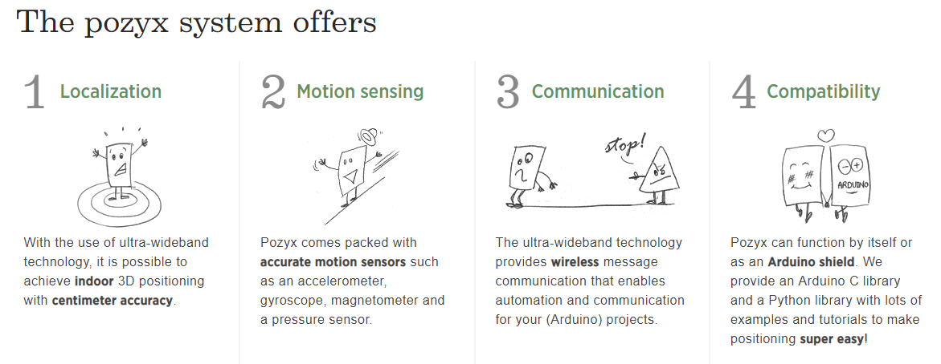

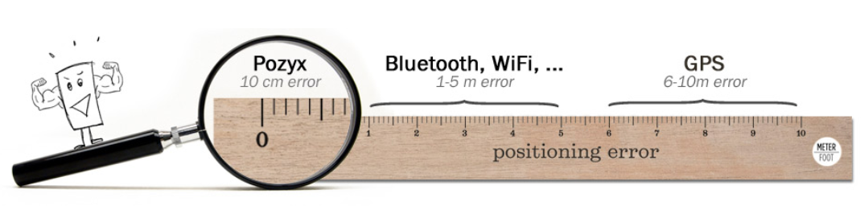

## Our Project

Our project involves extracting position data (x, y, z) and orientation data (pitch, roll, yaw) from both single and multiple Pozyx tags and streaming that data into a virtual environment, such as Unity3D, in real-time. 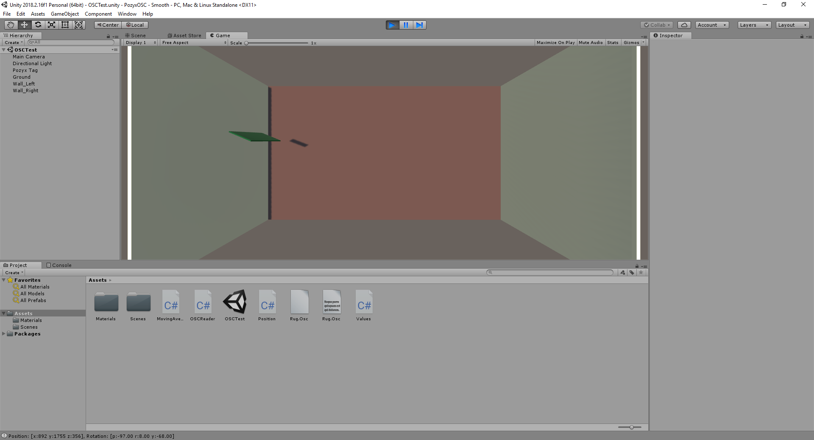

This lets us enter a virtual environment, as our current physical location, orientation and movement is accurately captured by the Pozyx system and mirrored in Unity. In addition, we are able to fully interact with that virtual environment through the utilisation of Unity’s object collision detection systems.

In this way, moving to a particular location, or making a specific gesture, in the physical world, could trigger unique responses in the virtual one.

For example, we have had two people hold a tag and move around the CUBE space. These are represented as GREEN cards in Unity. As the tags get physically close to each other, they change to RED in Unity, going back to GREEN as they separate again.

We would now like to demonstrate our project to you.

We feel this system offers countless opportunities for exciting research / project applications.

More advanced projects could incorporate more complex virtual worlds and / or utilise additional IoT devices, such as turning lights on / off / changing colour (Phillips Hue)/

*Brainstorming begins…